**Title: To createa dynamic web app**

**Services used: Lambda, S3, API Gateway, DynamoDB, Postman API**

Click on services

Click on s3 , click on create bucket

Uncheck block all permissions and check block pubic cross account,

Check I acknowledgment, click on create bucket

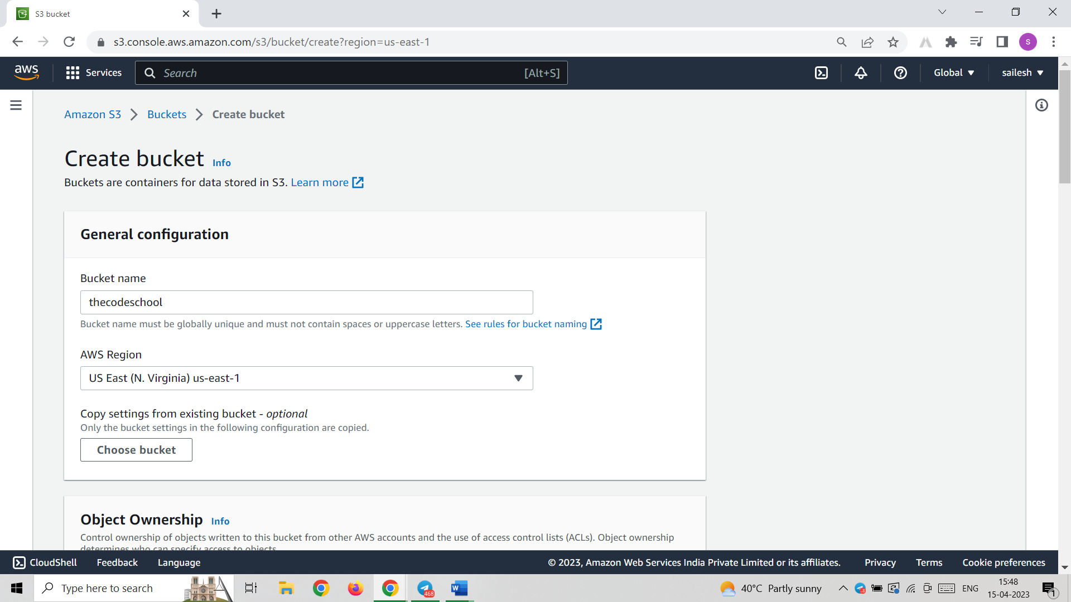

Upload error.html, index.html file in that bucket

Then select the files and click on action select make public with alc accces

Go to the created bucket and go to properties click on static website hosting

Click on enable and give names

Index.html

Error.html

Then save changes

Open link createedin static website hosting

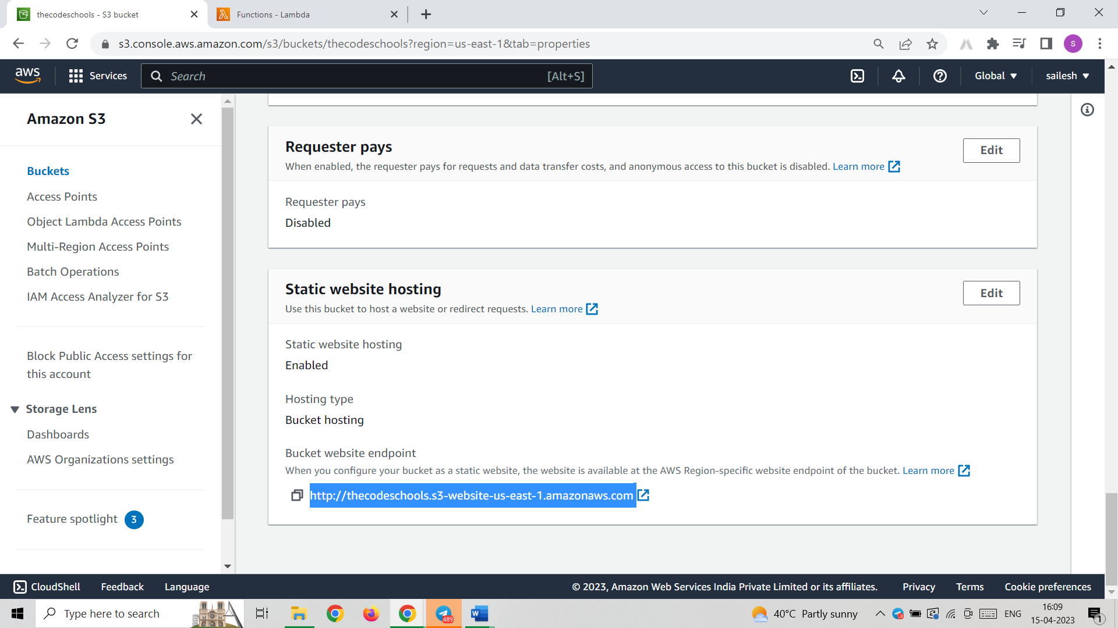

Step-2 : create lambda function

Name Hello worldFunction

Change language to python 3.8

Then click on create function

Write the code

# import the json utility package since we will be working with a JSON object

**import json**

**def lambda_handler(event, context):**

**# extract values from the event object we got from the Lambda service and store in a variable**

**name = event['firstName'] +' '+ event['lastName']**

**# return a properly formatted JSON object**

**return {**

**'statusCode': 200,**

**'body': json.dumps('Hello from Lambda, ' + name)**

**}**

**Create an event and write json**

**{**

**"firstName": "Ada",**

**"lastName": "Lovelace"**

**}**

**Ctrate an event**

**In json write**

**{**

**"firstName": "Ada",**

**"lastName": "Lovelace"**

**}**

**Step-3**

**Create an Api Gateway**

**Click on build for first rest api**

**Click on create new api**

**API name: HELLOWORLDAPI**

**ENDTYPE: Edge Optimized**

**Click on creae api**

**Click actions -> clic on create method ->select post**

**In lambda function give name -> HelloWorldFunction**

**Click save**

**Next**

**Click actions-> click enable cors**

**Click enable cors-> click yes**

**Click actions -> click deploy api**

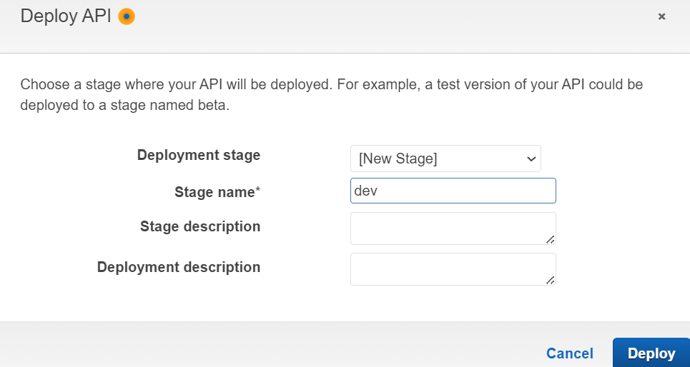

Click deploy, click save changes

Copy invoke url: <https://53g6u8pr94.execute-api.us-east-1.amazonaws.com/dev>

Open post man copy the url

And select post

Then in event space write

{

"firstName": "nac",

"lastName": "greenwood"

}

Step-4: creating dynamdb table

Click on create table

**Click create table**

**Copy arn of dynamodb table**

**Go to lambda functon which we created then click on configuration-> permissions-> click on role name**

**Add permissions-> attach inline policy**

**Click json**

**{**

**"Version": "2012-10-17",**

**"Statement": [**

**{**

**"Sid": "VisualEditor0",**

**"Effect": "Allow",**

**"Action": [**

**"dynamodb:PutItem",**

**"dynamodb:DeleteItem",**

**"dynamodb:GetItem",**

**"dynamodb:Scan",**

**"dynamodb:Query",**

**"dynamodb:UpdateItem"**

**],**

**"Resource": "arn:aws:dynamodb:us-east-1:780228447952:table/HelloWorldDtabase"**

**}**

**]**

**}**

In place of arn we have to paste our dynamo db table arn, click on review policy

Give name and click on create policy

Back to lambda

In code pasthe the full lambda code from github

**# import the json utility package since we will be working with a JSON object**

**import json**

**# import the AWS SDK (for Python the package name is boto3)**

**import boto3**

**# import two packages to help us with dates and date formatting**

**from time import gmtime, strftime**

**# create a DynamoDB object using the AWS SDK**

**dynamodb = boto3.resource('dynamodb')**

**# use the DynamoDB object to select our table**

**table = dynamodb.Table('HelloWorldDatabase')**

**# store the current time in a human readable format in a variable**

**now = strftime("%a, %d %b %Y %H:%M:%S +0000", gmtime())**

**# define the handler function that the Lambda service will use as an entry point**

**def lambda_handler(event, context):**

**# extract values from the event object we got from the Lambda service and store in a variable**

**name = event['firstName'] +' '+ event['lastName']**

**# write name and time to the DynamoDB table using the object we instantiated and save response in a variable**

**response = table.put_item(**

**Item={**

**'ID': name,**

**'LatestGreetingTime':now**

**})**

**# return a properly formatted JSON object**

**return {**

**'statusCode': 200,**

**'body': json.dumps('Hello from Lambda, ' + name)**

**}**

Click deploy-> test

IN DYNAMO DB TABLE Create items

ID- name

Run the code in lamda and return to dynamo db click explore table events

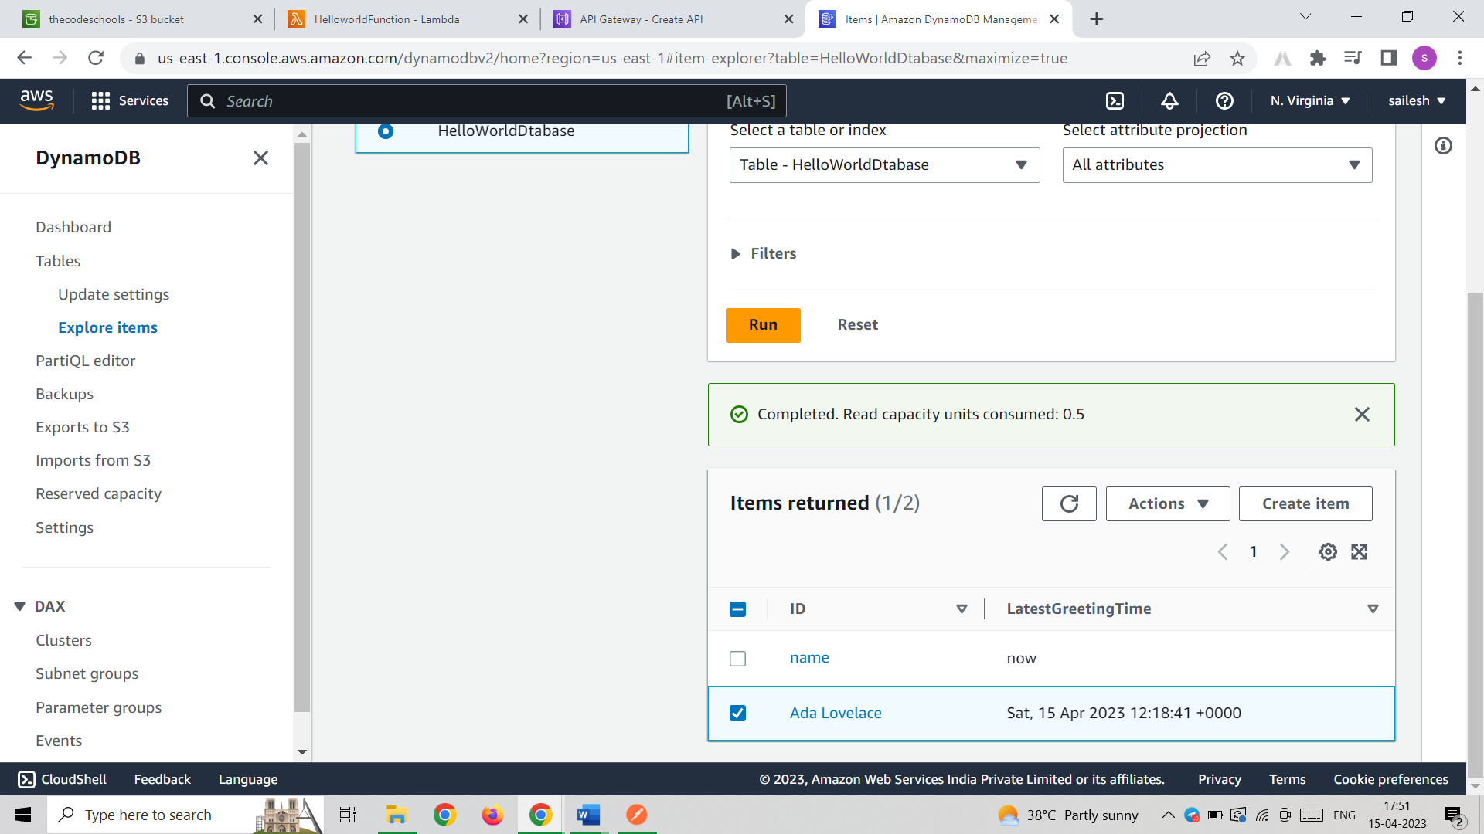

We will se that love lace which we given in lambda event.

Finally go to s3 bucket-> properties

Go to static website hosting

Copy the endpoint code paste in new tab

